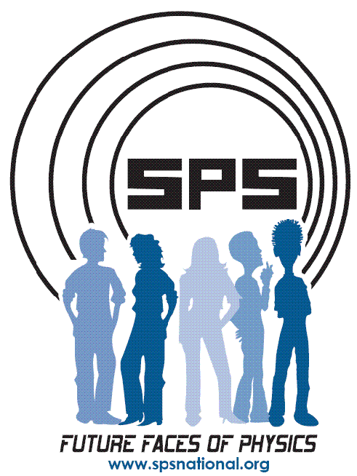
Host Manual
Jeopardy!

JEOPARDY!

Fabulous fields

100. Of all the science disciplines, this “life” science has the most women in faculty positions (>20%).
-What is Biology?

200. Over 40% of students that major in physics and another field have their second major in this quantitative field.
-What is mathematics?

300. Females make up about 5% of the full professors in physics departments.
In this ancient and closely-related field, that number is doubled.
-What is Astronomy?

400. Of astrophysics, condensed matter physics, and plasma physics, the most physics PhDs are awarded for work in this subfield.
-What is condensed matter?

500. In 1988, the University of Wisconsin and Wayne State offered the first accredited programs in this high-paying field of applied physics.
-What is medical physics?

Rock and Roll Physics

100. Of diamond, graphite, quartz, and charcoal, this is the one not made from carbon.
-What is quartz?
200. Of a basketball, bowling ball and car tire, this one rolls down a ramp fastest.
-What is a bowling ball?

300. The T in MOSFET, this item is critical to the audio amplifiers that most rockers like to crank up to "11".
-What is a (Metal-Oxide-Semiconductor-Field-Effect)-Transistor?

400. For wheels, this force is usually much smaller than either its sliding or static counterparts.
-What is rolling friction?

500. While some claim the moon is yellow or the color of green cheese, most people, upon examining a moon rock, would say that it is this color because of its albedo of 0.12.
-What is black? (What is dark gray? also acceptable)?

What’s in a Name

100. This physicist calculated that black holes should emit radiation until they evaporate. He is almost completely paralyzed from ALS, or Lou Gehrig’s disease.
.-Who is Stephen Hawking?

200. The Nobel Prizes in Chemistry has been given to 3 women. This woman and her daughter each received one for work on radioactivity.
-Who is Marie Curie?

300. The second female to win a Nobel Prize in physics, Maria Goeppert-Mayer, won for this model.
-What is the nuclear shell model? (“What is the shell model?” also accepted)

400. By approving Edward Bouchet’s dissertation “On Measuring Refractive Indices”, this ivy league school because the first American university to grant a PhD to an African American.
-What is Yale?

500. This iconic physicist was engaged in many civil rights activities and co-chaired the American Crusade to End Lynching.
-Who is Albert Einstein?

Extreme Planets

100. This planet has the highest mean surface temperature.
-What is Mercury?

200. This former planet has a moon with nearly half its diameter.
-What is Pluto?

300. This planet has the largest angular momentum about our sun.
-What is Jupiter?

400. Of the 8 official planets, it could almost be considered a double planet, with the largest moon relative to its size.
-What is the Earth?

500. Galileo described this lowest density planet as having "ears".
-What is Saturn?

Pop Culture

100. In this 1997 film, based on a book by astronomer Carl Sagan, Jodi Foster’s character meets extraterrestrial beings.
-What is Contact?

200. This new CBS sitcom revolves around two theoretical physicists and their pretty neighbor.
-What is The Big Bang Theory?

300. Physicist Lawrence Krauss wrote this popular “physics of” book for Voyager fans.
-What is The Physics of Star Trek?

400. The guitarist from this legendary English band recently defended his PhD work in astrophysics.
-What is Queen?

500. John Lithgow played a physics professor in this wacky NBC sitcom (1996-2001).
-What is 3rd Rock from the Sun?

DOUBLE JEOPARDY!

On the Hill

200. Increasing diversity in science is a priority of this agency, commonly known as “NSF”, which funds fundamental science and engineering.
-What is the National Science Foundation?

400. Bart Gordon, chair of the House Committee on Science and Technology, represents this state.
-What is Tennessee?

600. Often called “RAGS”, this 2006 report warned that the US may be falling behind other countries in science competitiveness.
-What is Rising Above the Gathering Storm?

800. Before becoming science advisor to the President, Physicist Jack Marburger was director of this Long Island-based national lab, which specializes in nuclear physics.
-What is Brookhaven National Laboratory?

1000. There are currently two congressmen with PhDs in physics. Name one.
-Who is who is Vernon Ehlers or Rush Holt?

Future Faces
200. Prada and Calvin Klein market glasses as accessories, but many people opt for this procedure so they don’t need to wear them.
-What is LASIK?

400. The popularity of gels, strips, and lights that produce this sparkly effect has exploded recently – but even ancient Egyptians saw it as a sign of status.
-What is white teeth?

600. This haircut, named after the popular sitcom character who debuted it in the mid 1990s, will eventually be as outdated as "The Farrah.”
What is “The Rachel”?

800. In 2005, 2.7 million cosmetic surgeries were performed on this area of the face; making it the top ranking cosmetic surgery site for people ages 51-64.
What is the eyebrow?

1000. Coming in second to liposuction, this is the next most popular cosmetic surgery for men.
What is rhinoplasty / nose job?

Tenure-Worthy

200.
Who is Newton?

400.
Who is Hubble?

600.
Who is Ampere?

800.
Who is Taylor?

1000.
Who is Schrodinger?

Changing Fashions

200.
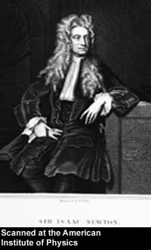
Who is Isaac Newton?

400.
Who is Marie Curie?

600.
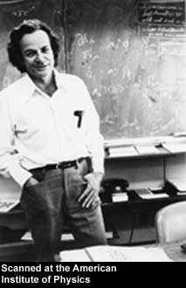

Who is Richard Feynman?

800.
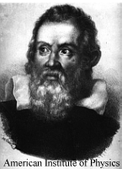
Who is Galileo Galilei?

1000.
.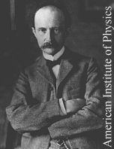
Who is Max Planck?

Sci-Fi to Real Life

200. This fictional "beam" that moved people from one place to another in Star Trek now has a real-world equivalent -- using photons, not atoms yet.
What is a transporter beam?

400. The P in PET scans, this anti-particle is used to study the sources of medical seizures in the body.
What is positron? (Positron Emission Tomography)

600. The S in LASER, this word describes a process that contrasts with "spontaneous" emission of light, producing monochromatic rays.
What is stimulated? (Light Amplification by Stimulated Emission of Radiation)

800. Philo T. Farnsworth is often credited with this invention, in which images are transmitted via electromagnetic radiation.
What is the television?

1000. True to the sound of her name, she taught everyone "how" to slow light down to bicycle speeds in 1998.
Who is Lene Hau?

